AP formula: Sn = (n/2)[2a + (n-1)(d)]

KB/MB/GB = 210/ 220/ 230 B

Rotational Delay = $\frac{60}{rpm}⋅{10}^{3} ms$

Avg Rotational Delay = $\frac{Rotational Delay}{2}$

Time to Read 1 Sector with Gap = $\frac{Rotational Delay}{number of \sec{t}ors} ms$

Time to Read 1 Sector **without** Gap = $\frac{Time to read 1 \sec{t}or with gap}{1 - \left(percentage of gap on track\right)} ms$

Transfer Time = (# sectors w gap * Time read w gap) + ( (#sectors - #sectors w gap) * Time read w/o gap)

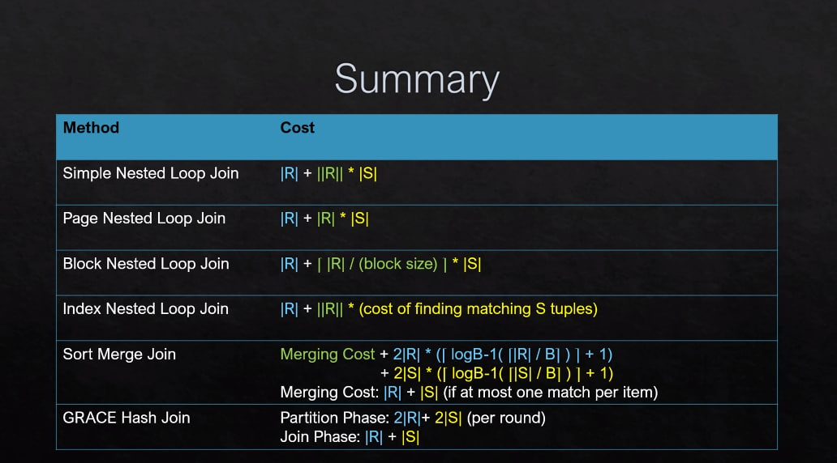*Note: GRACE Hash Join formula only applies if $B ≥ \sqrt{number of pages}$, if not repeatedly partition



(to be exact: $\frac{M}{B-1} ≤B-2$)

Repeated partition of hash join

* Incur 2|R| + 2|S| for each additional round
* New number of pages = M/(B-1)no. of additional partition

Hash-Index

* Format 1: 1.2 (1 if no overflows)
* Format 2: 1.2 (1 if no overflows) + Cost of finding S tuples (depends on no. of matching page/tuples for clustered/unclustered)

B-trees

* Finding Order of B+ tree, d: (2d+1)(ptr_size) + (2d)(key_size) <= page_size
  + ‘d’ will round down, m = 2d (m must be divisible by 2) ***implication: m must be an even number
  + Height of B+ Tree = $↱\log_{m}{}total number of records↰$
  + 

**Given F = Fanout = 2d - 1, N = # of Records  
General Formula for number of levels is:**

* For a n-level B+-tree, the minimum number of data entries is 2d(d+1)n-2 [1-level tree: d]
* For a n-level B+-tree, the maximum number of data entries is 4d(d+1)n-2 [1-level tree: 2d]
* Total cost (of finding matching tuples) = Cost for format 1/2/3 + Cost for clustered/unclustered (for format 2/3) + Additional leaf node if data entries across multiple nodes?
  + Cost for format 1/2/3: height of the tree (includes first leaf node) [index is in memory]
  + Cost for clustered: Each data page is only fetched once (1 I/O per required page)
  + Cost for unclustered: Each data record is fetched (1/O per required data tuple/pointer)
* d <= keys <= 2d only applies for format 2, format 1 and 3 (except for leaf nodes)

Multi-way Merge Sort:

* Size of 1 run: Usually B
* No. of passes = $1+\left\lceil \log_{B-1}\left\lceil N/B\right\rceil \right\rceil$ (If generating runs included) *** alternatively divide manually since this formula somehow gives weird answers sometimes
* Cost = 2N*(No. of passes)
* To merge in one pass, #sorted runs <= number of available input buffers

Replacement Selection (freeze if new value <= old value)

* Average length of a run: 2B
* Min length of a run: B (Worst case: when file is sorted in descending order) -> same as quicksort
* Max length of a run: M (Best case: when file is sorted in ascending order)

Sort-Merge Join

* Best Case: Largest value in R < Smallest value in S => Merging Cost: |R| + 1 ***when R and S near sorted/already sorted?
* Worst Case: Each tuple of R requires scanning entire S => Merging Cost: |R| + |R|*|S|

GRACE Hash Join

* Min no. of partitions during partition phase:
  + Each partition uses B-1 pages (1 reserved for input)
  + No. of partitions = M/B-1
* Max no. of partitions during partition phase:
  + Each partition uses only M/B-1 page
  + No. of partitions = B-1

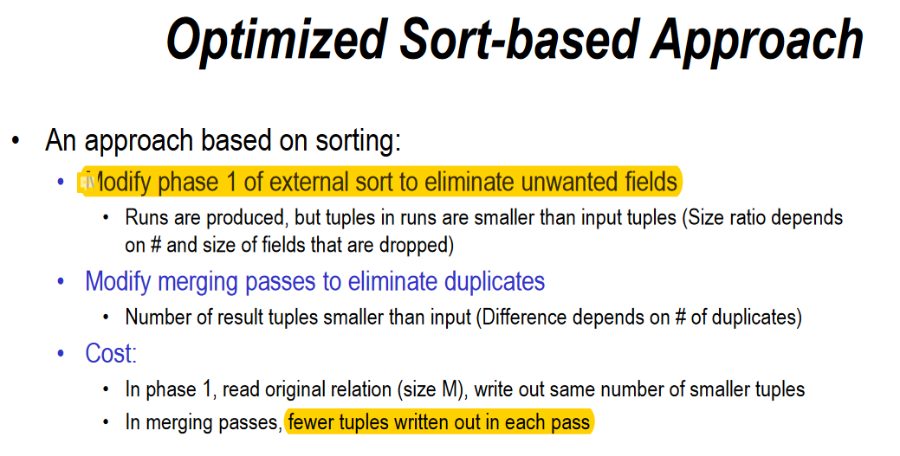

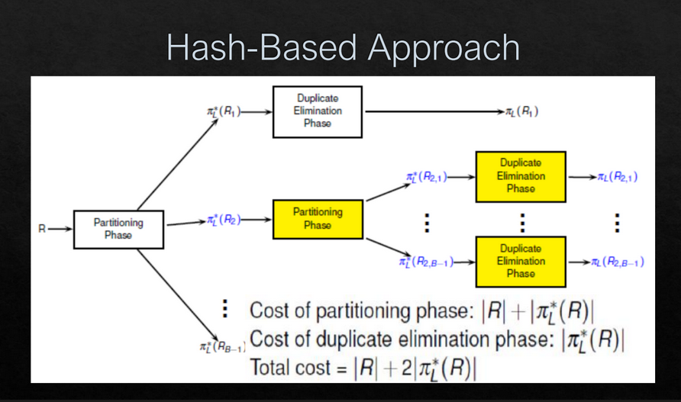

**Query optimization**

Q: When do we use on-the-fly for selection/projection?

A: I think it is only for those selection/projection AFTER join

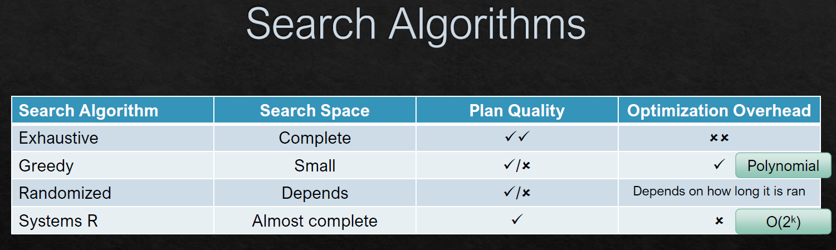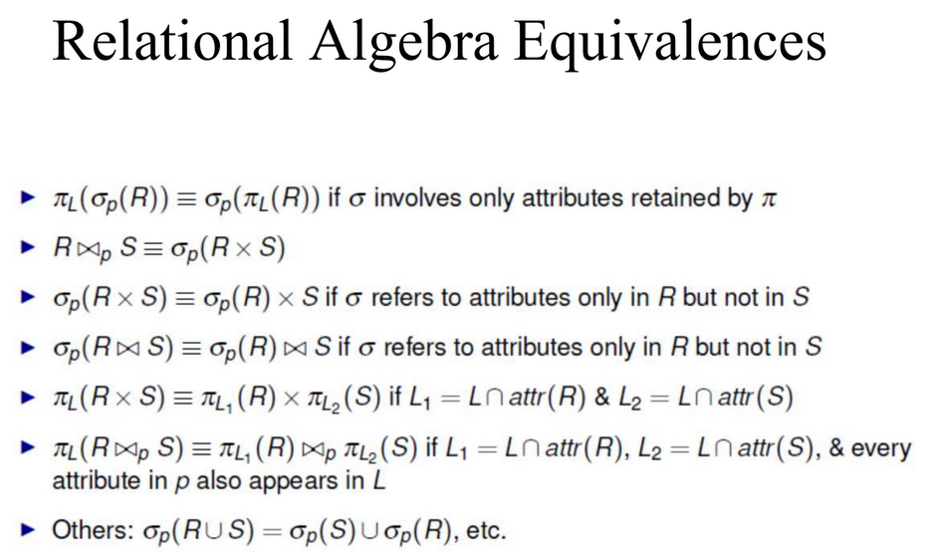

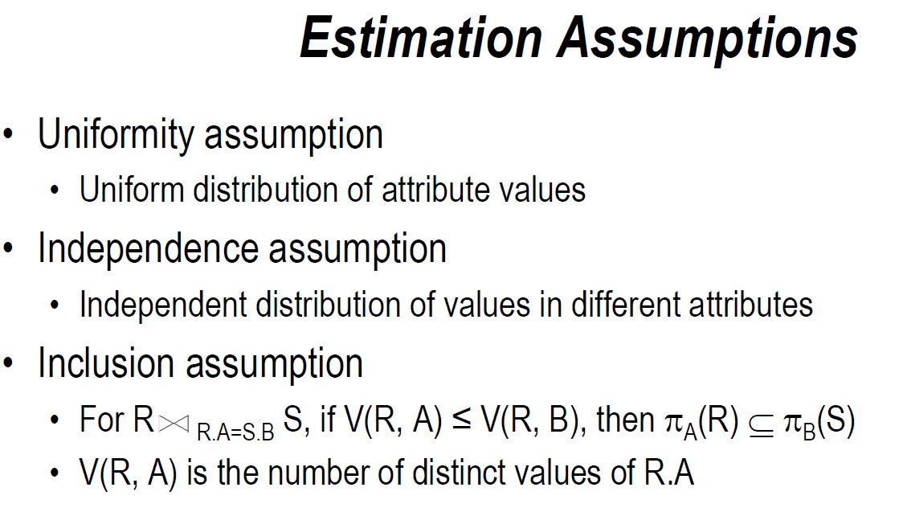

Standard steps for estimation questions:

1. Pure Selection ($W= σ(z=val)R$) => Use uniform distribution assumption
$\left|\left|W\right|\right|= \frac{|\left|R\right||}{V\left(R,Z\right)}$

2. Range Selection ($W= σ(z≥val)R$)
$f= \frac{Max-val+1}{Max-min+1}$

$\left|\left|W\right|\right|=f*|\left|R\right||$

3. Single Join, Single Predicate (W = R1 |><|R1.B = R2.B R2)
$\left|\left|W\right|\right|= \frac{\left|\left|R1\right|\right|*|\left|R2\right||}{max⁡(V\left(R1,B\right), V\left(R2,B\right))}$

4. Single Join, Multiple Predicates (W = R1 |><|R1.B = R2.B /\ R1.C = R2.C R2)
   1. Apply Single Join, Single Predicate on B => obtain intermediate relation U
   2. Update the values of V for the intermediate relation
      1. For join attribute, V(U, B) = min(V(R1, B), V(R2,B))
      2. For the other attributes (such as C):
         1. V(U,C) = min(sizeOfOutput, max(V(R1,C), V(R2,C))
   3. Apply Pure Selection on U (for attribute C)
5. Multiple Joins
   1. Apply Single Join, Single Predicate on 2 relations first
   2. Update the values of V for the intermediate relation
      1. For join attribute, V(U, B) = min(V(R1, B), V(R2,B))
      2. For the other attributes (such as C):
         1. V(U,C) = min(sizeOfOutput, max(V(R1,C), V(R2,C))
   3. Apply Single Join, Single Predicate against the 3rd relation (repeat the same process)
   4. Resolve any leftover predicates (Update value of V in each iteration)
6. Select Before Join
   1. Apply Pure Selection
   2. Update ALL values of V for the intermediate relation (newV = min(sizeOfOutput, oldV)
   3. Apply subsequent join operators respectively

Concurrency Control

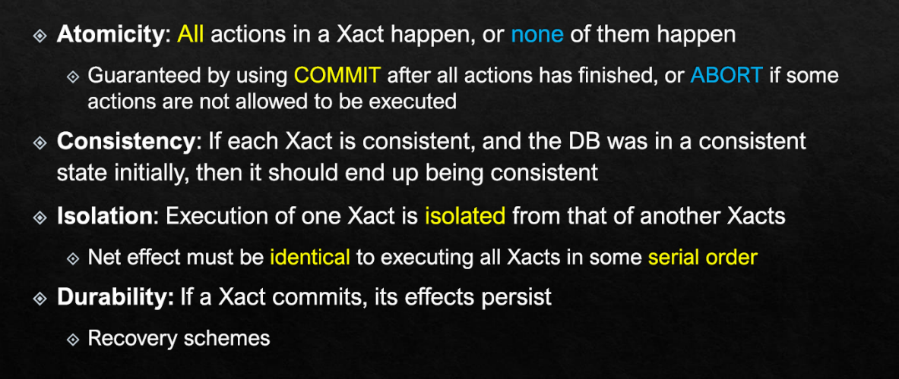

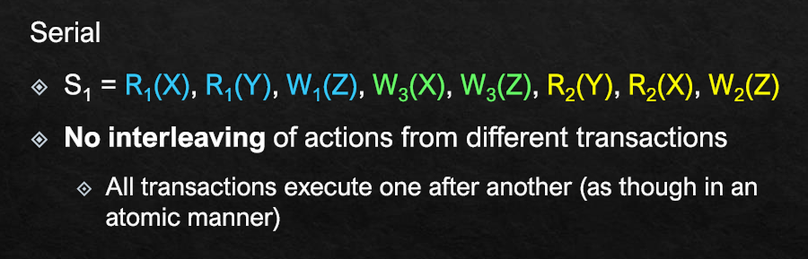

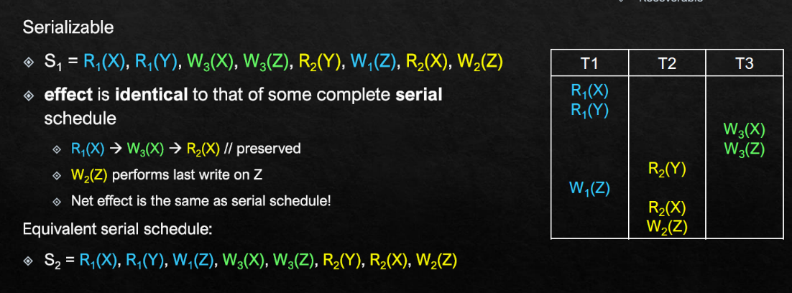

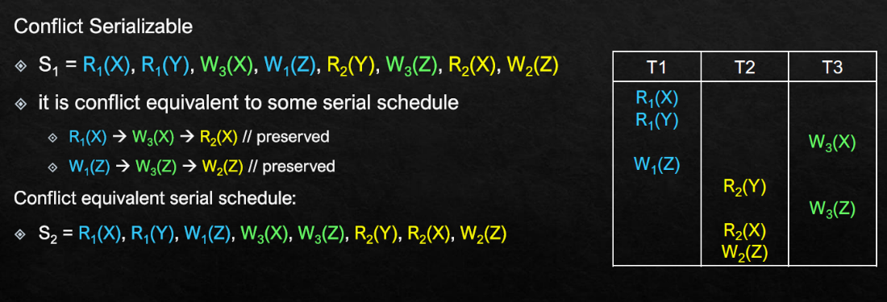

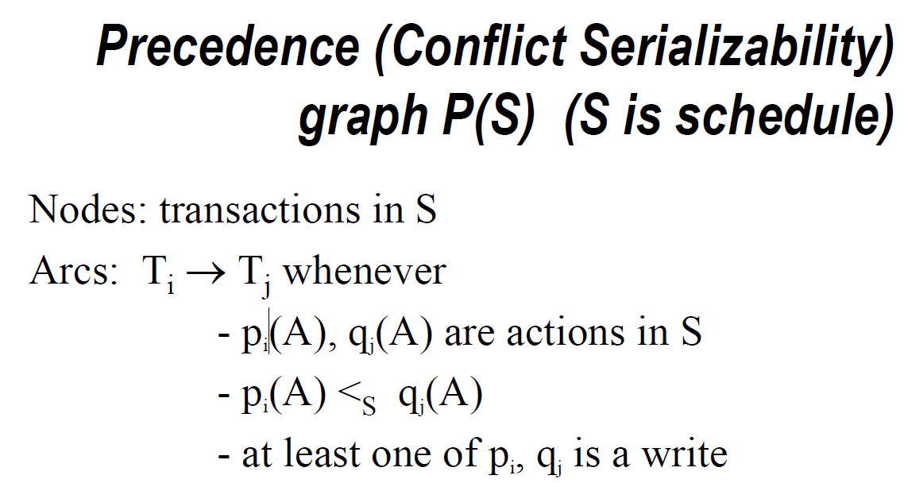

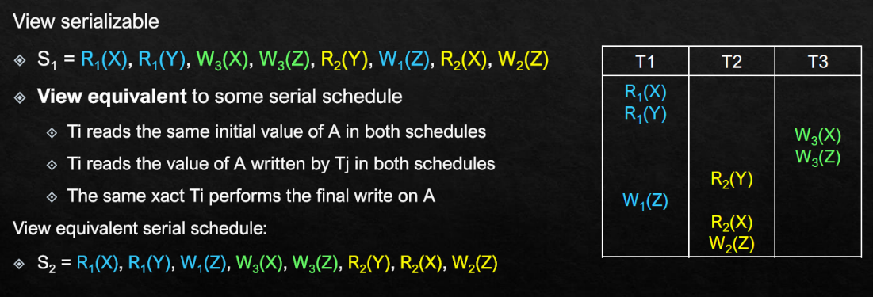

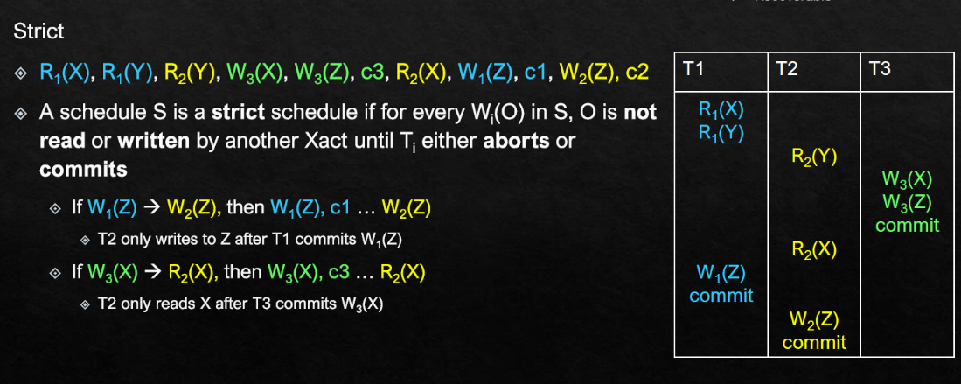

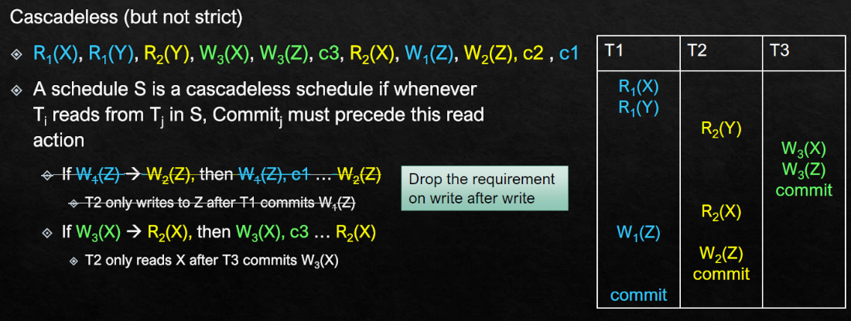

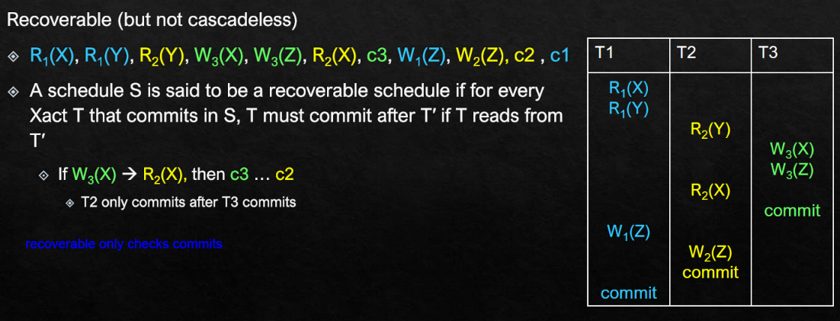

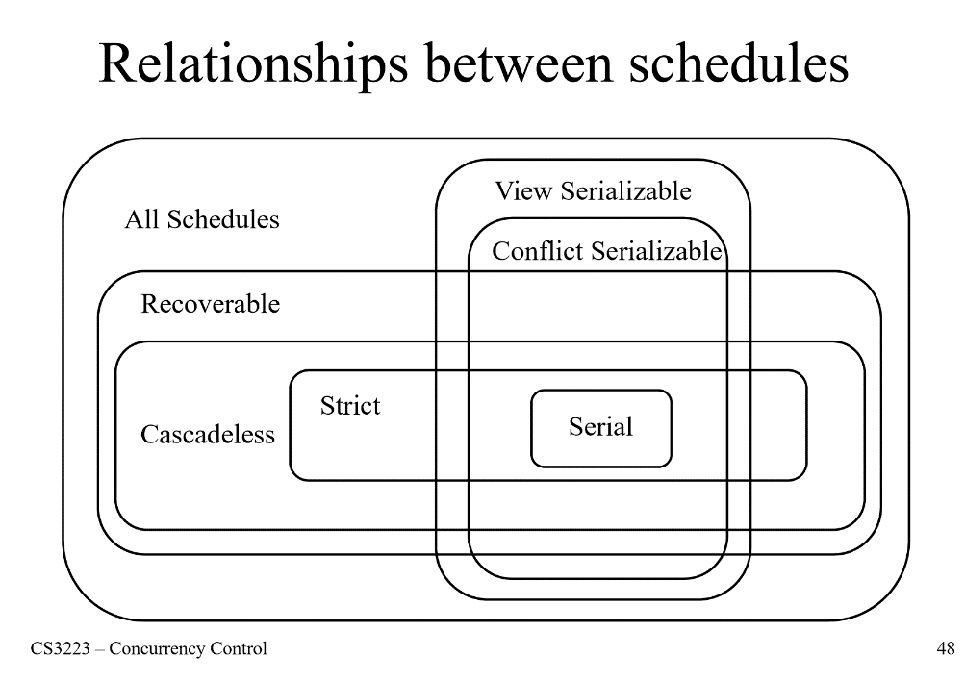

Q: How to check for serializability?

1. For each object, check the order of conflicting actions
2. “Combine” all of these orders, and check if there are any cycles

Q: How to check for conflict equivalence?

1. For each object, check the order of conflicting actions
2. Repeat for all COMMITTED transactions => compare to see if the order is the same

Q: How to check for conflict serializability?

1. Draw Precedence Graph (refer to the screenshot in the previous page).

Q: How to check for view equivalence?

1. For each object, check its initial read in both schedule and ensure that they are the same
2. For each READ in both schedule, check if it reads from the same “place”
3. For each object, check its final write in both schedule and ensure that they are done by the same xact.

Q: How to check for view serializability?

Option 1: Draw Polygraph (only works each xact only write to an object ONCE)

1. Add T0 and Tf nodes
2. For each READ in the schedule, draw an arrow from source to itself
3. Look at each write and its object (T3, X)
4. Look at every edge with X (that doesn’t involve T3)
5. Add either T3 pointing to start or end pointing to T3
   1. Eg. Original Edge = 1->2 => Becomes 3 -> 1 -> 2 -> 3
   2. Do not add any edge pointing to T0 and pointing from Tf

Option 2: Brute force each possible serial schedule, and check for view equivalence

Q: How to check for cascadeless/recoverable/strict?

1. Focus on the READ actions for cascadeless/recoverable
   1. Cascadeless: A schedule S is a cascadeless schedule if whenever Ti reads from Tj in

S, Commitj must precede this read action

* 1. Cascadeless schedules are also recoverable schedules

1. Focus on the WRITE actions for strict
   1. Strict schedules are also cascadeless schedules

Q: How to check if a schedule can be generated under basic 2PL?

1. Check for the growing/shrinking phase of each xact

Q: How to check if a schedule can be generated under shared lock 2PL?

1. Check for the growing/shrinking phase of each xact
2. Check compatibility matrix for any violations

Q: How to check if a schedule can be generated under strict 2PL?

1. Check for the growing/shrinking phase of each xact
2. Check for all xacts, it must hold on to the lock until it commit/abort

2PL – transaction **increases** in the number of locks it holds, then afterwards only **decreases**

2PL -> will be **conflict serializable** for committed xacts BUT not the other way around

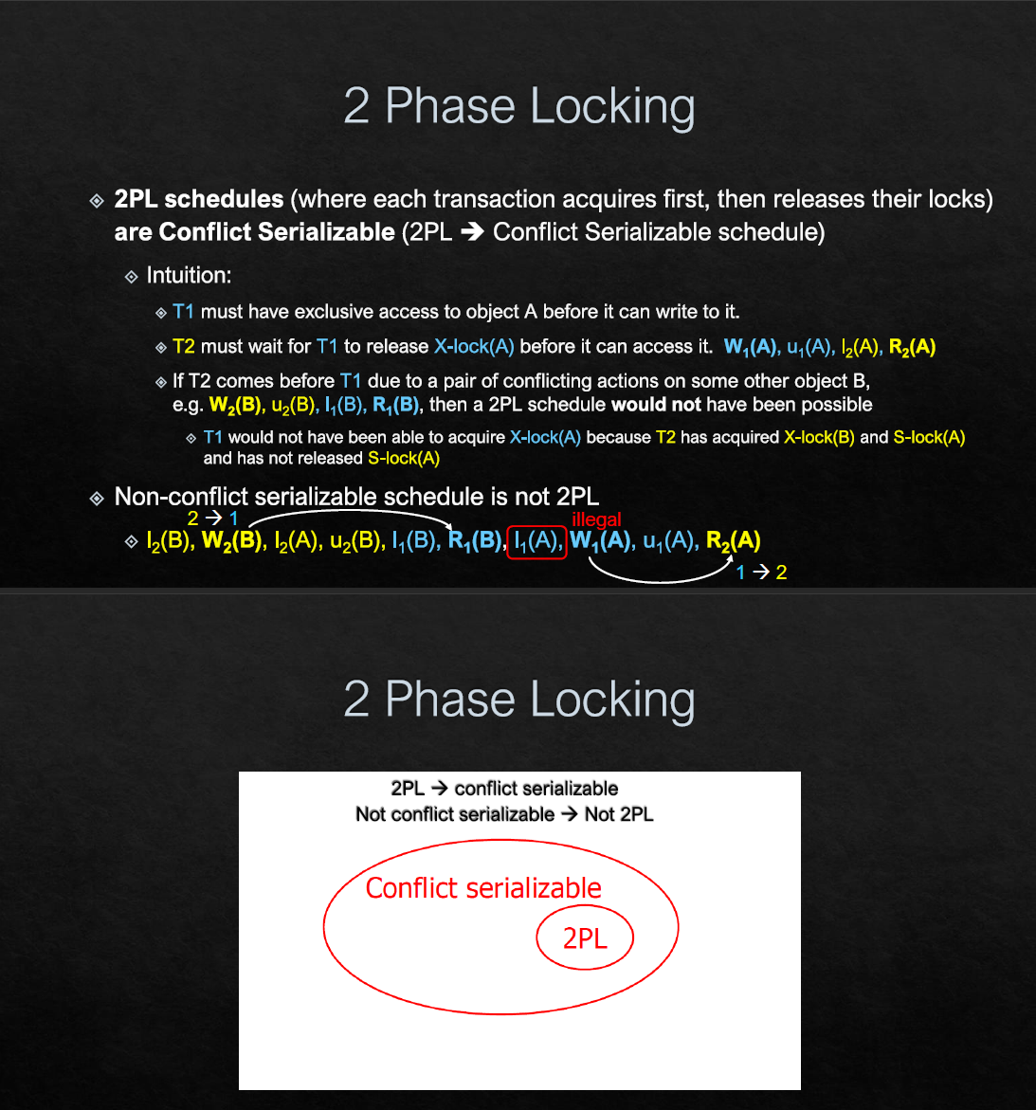

Strict 2PL -> guarantees consistency, can still have deadlocks.

* Will not have dirty reads
* Can have deadlocks
* Always view serializable
* Will not result in unrepeatable reads

Abort -> release all locks

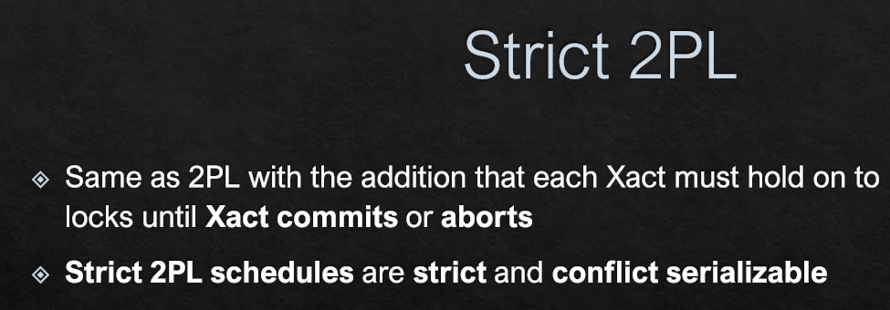

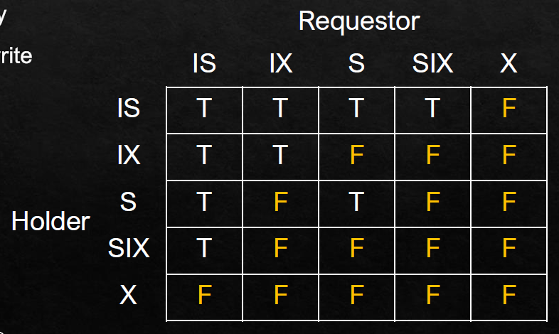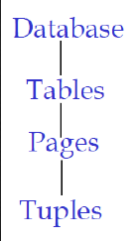

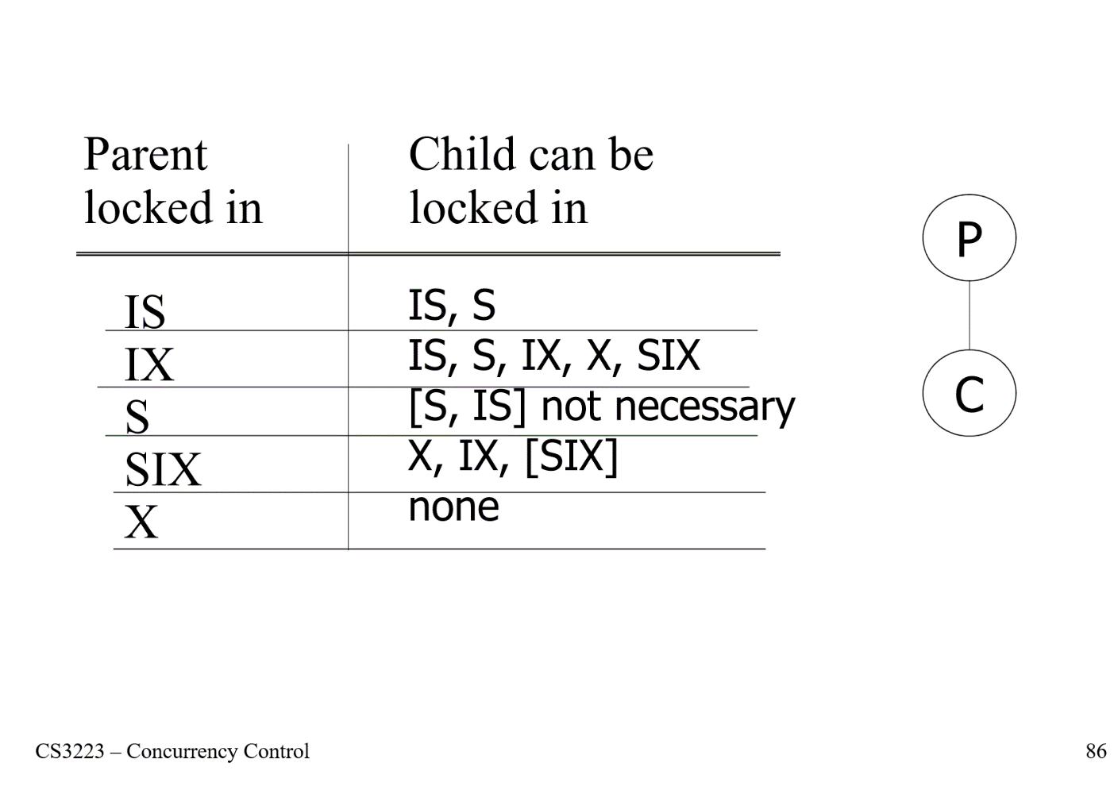

IS/IX: Intent to lock at a FINER granularity

SIX: Read now + intent to lock at a FINER granularity (maybe need to read 1 entire page now but only write to 1 tuple)

Deadlock

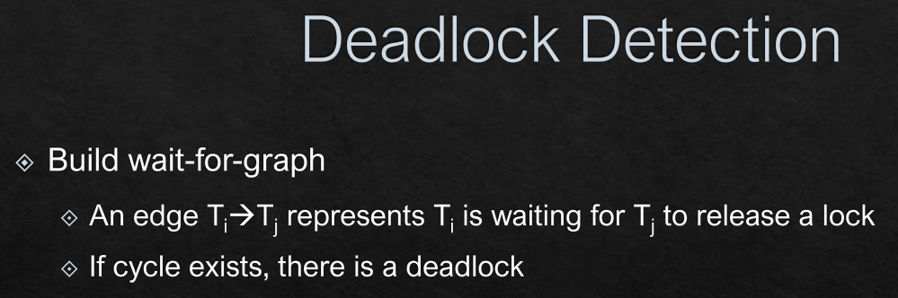

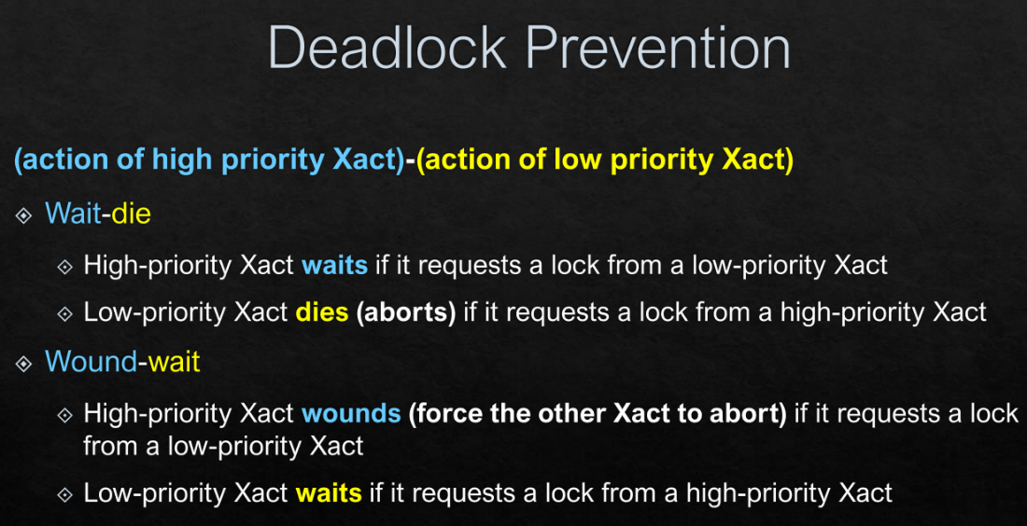

Optimistic Concurrency Control/Validation based protocol

* Can never have dirty reads
* Can never have deadlocks
* Can never have unrepeatable reads
* Can never have cascading aborts
* Can have starvation

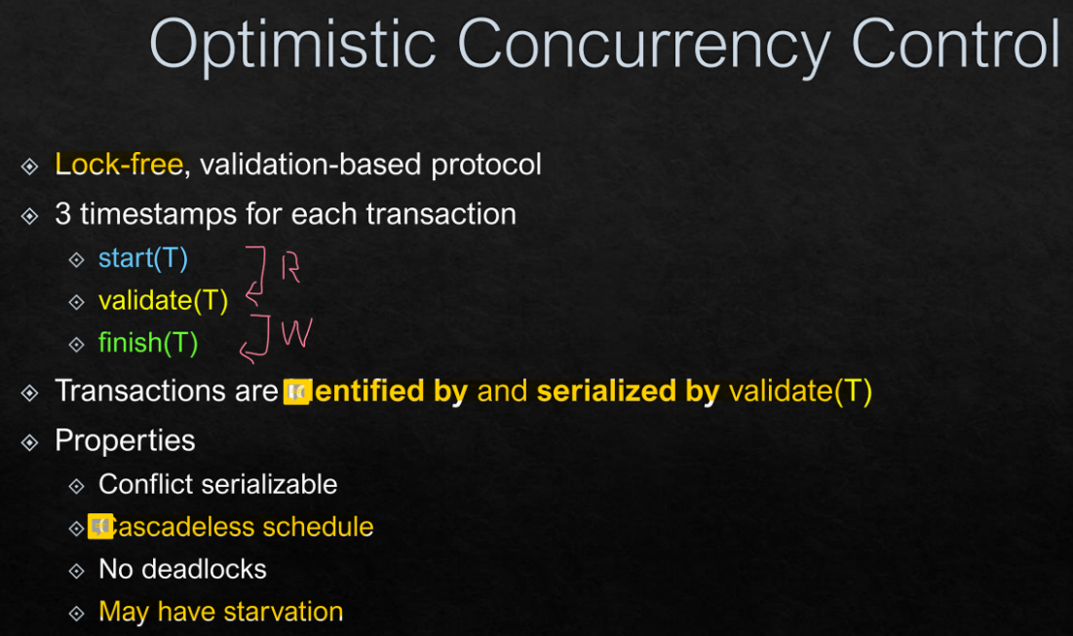

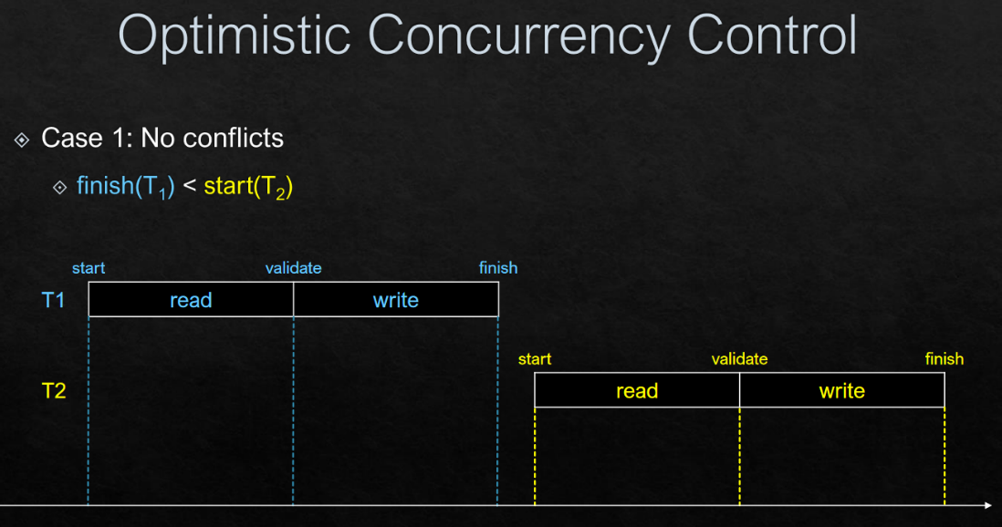

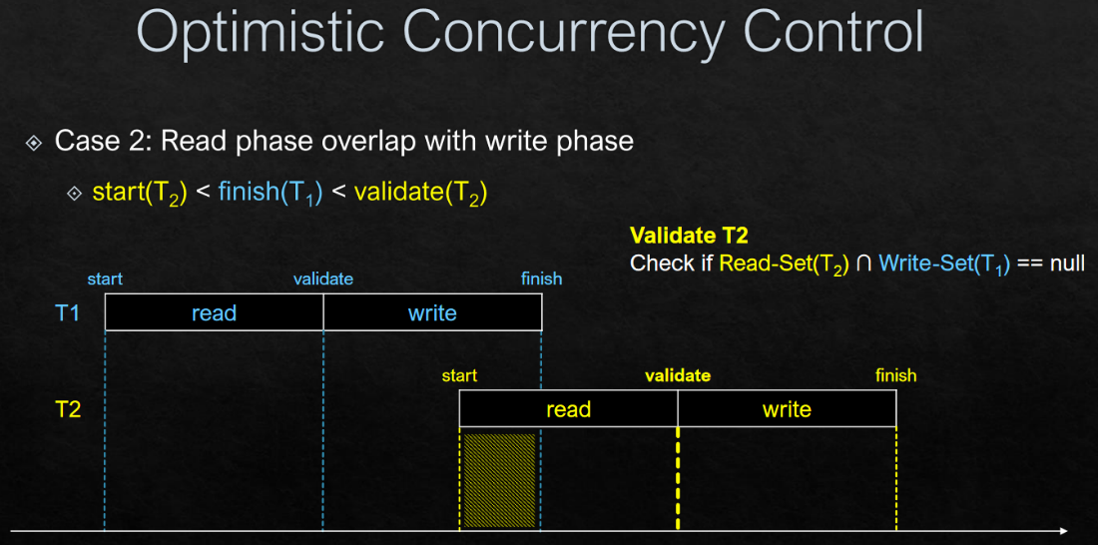

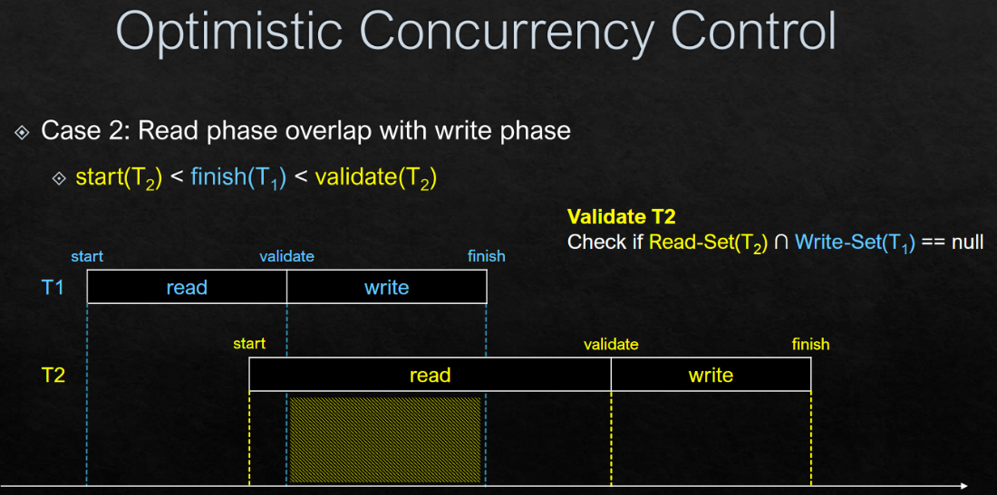

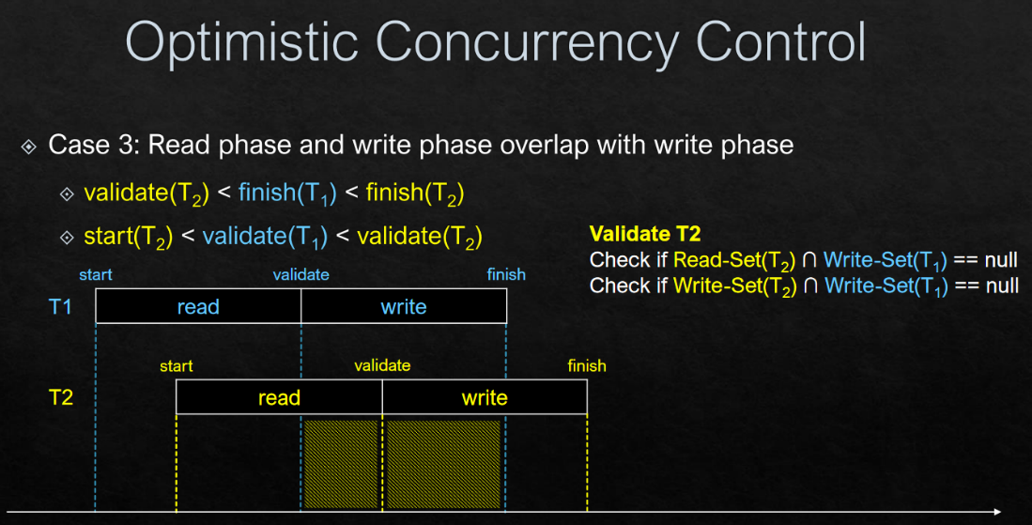

Steps to solve common validation questions:

1. First validation is always successful
2. For subsequent validations, compare against each validation that happened before it
   1. When comparing, if RW set of current xact does not overlap with the W set of target xact => instant success
   2. If target xact is already aborted, just ignore it
   3. Else, check if its under Rule 1/2/3
      1. Rule 2: Current validation after target finish + Current start before target finish
         1. R - W
      2. Rule 3: Current validation before finish
         1. RW – W
3. If validation fail -> abort

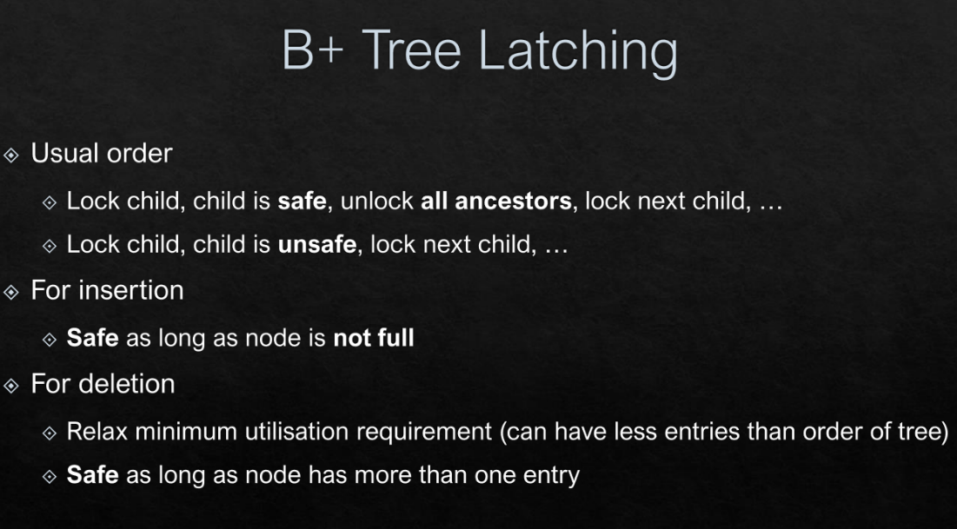

^ by right for deletion, it should be more than half full. By relaxing this requirement, it increases concurrency/efficiency.

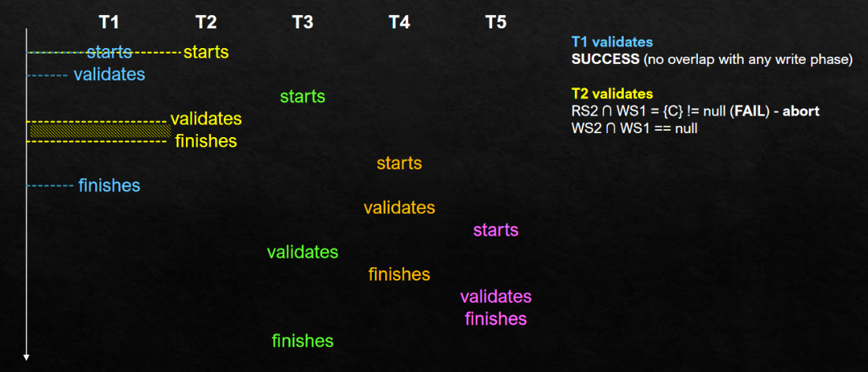

Logging

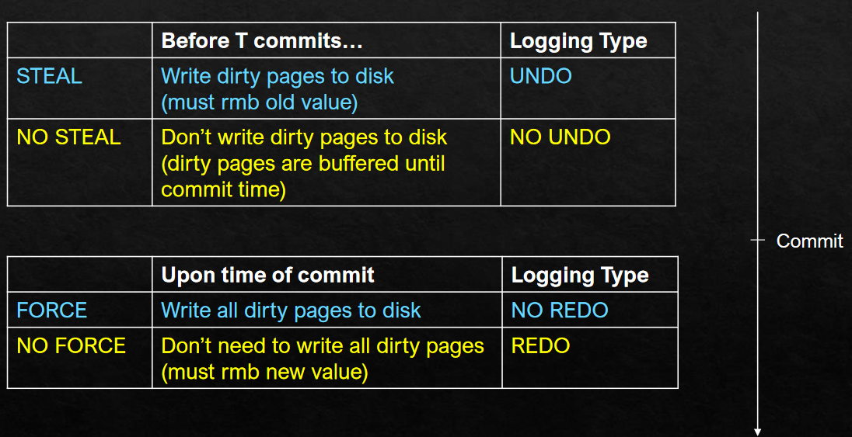

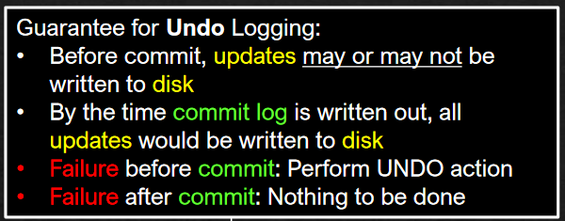

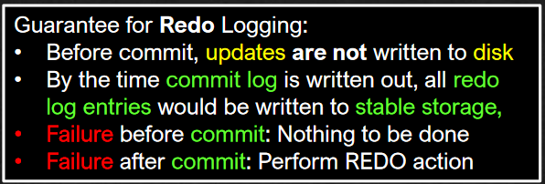

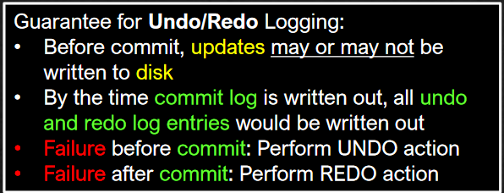

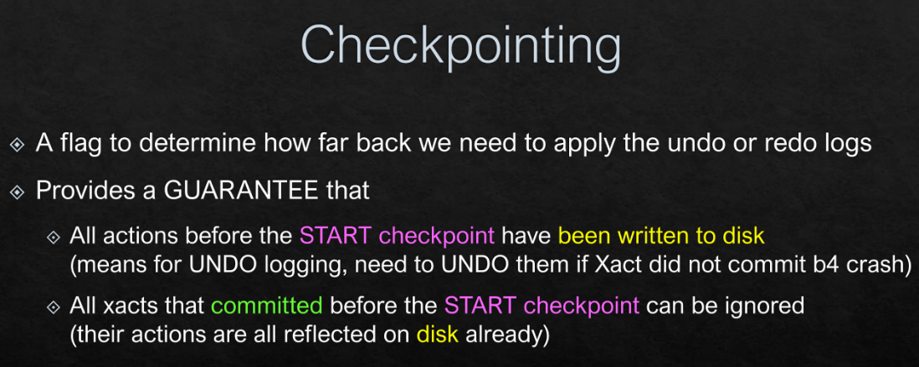

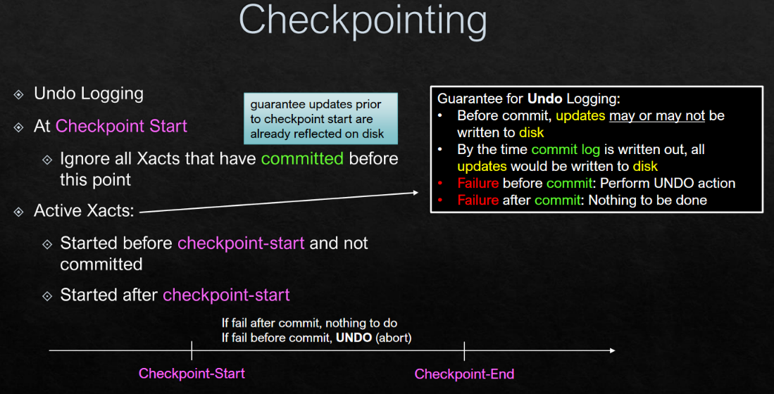



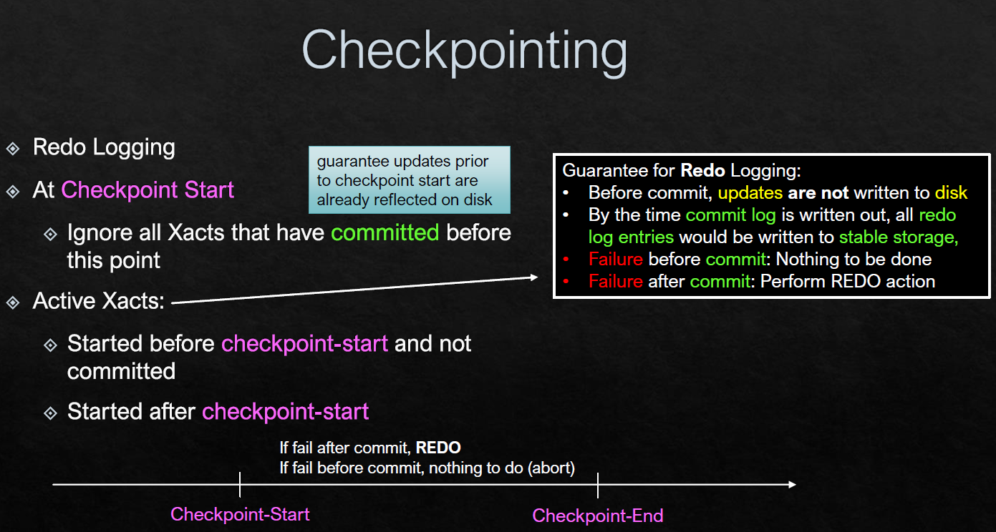



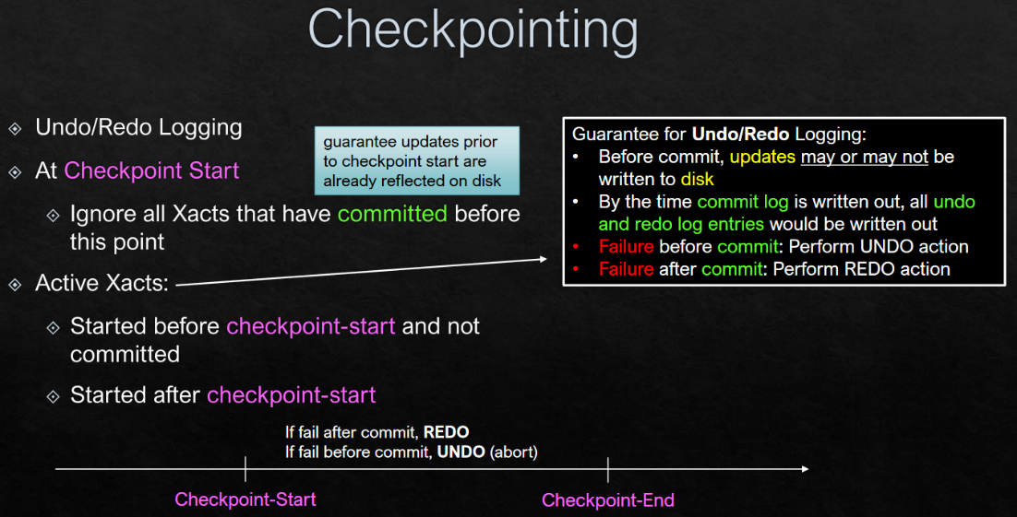



**\*If there is no END/crash before END, we cannot ignore all committed xacts before start**

**\*If there are multiple checkpoints, use the latest one**

**\*All active xacts must commit or abort before end ckpt (for UNDO log)**

**\*Before recovery:**

**> Before commit: May or may not be reflected (UNDO), MUST not be reflected (REDO)**

**> After commit: MUST be reflected**

Q: How to approach checkpointing questions?

A: First, identify all active xacts (started before START but not committed + after checkpoint start).

Then apply undo/redo respectively:

Undo: Check for all uncommitted xacts (including before START!)

Redo: Only need to check for committed xacts AFTER START (Before start = ignore)